**CHAPTER 1**

**INTRODUCTION**

* 1. **OVERVIEW**

Emergency never comes with prior intimation and in real world scenarios, detecting such emergencies & reporting them is real challenge. Disaster management organizations, may its government or private one, have their own agenda in place to work-out on the plan and rescue the person who is in emergency. But many of such rescue teams/organizations complaints as they won’t get ‘right information in right time’. That is disaster management teams will not able to get the right information of the emergency in right time, so more the delay in reaching information of emergency to rescue team leads less chances of rescue.

Countries like US, where most of the old age citizens stay alone; separate from their children. Medical emergency is most important factor for such citizens. Even considering other personal emergencies like fire at home due to some unfortunate conditions and being alone, sleeping at home leads to major injuries; sometimes death. As per Indian governments ministry of road transport and highways departments report during the calendar year 2010, there were close to 5 Lakh road accidents in India, which resulted in more than 1.3 Lakh deaths and inflicted injuries on 5.2 Lakh persons. These numbers translate into one road accident every minute, and one road accident death every 4 minutes. Unfortunately more than half the victims are in the economically active age group of 25-65 years. The loss of main bread winner can be catastrophic. (Source: Government of India, Ministry of road transport and highways, transport research wing, New Delhi) In all such situations person who is in emergency will not be in position to inform disaster management team, and that is the worst situation where needy needs help but not able to seek it. So by any means if emergency is detected and reported automatically to disaster management team, then these teams will be in position to rescue person in emergency, even before he/she knows about such emergency.

To overcome these problems we propose a system including a user friendly android application and a system which runs with support of AWS. Amazon Web Services offers a broad set of global cloud-based products including compute, storage, databases, analytics, networking, mobile, developer tools, management tools, IoT, security, and enterprise applications: on-demand, available in seconds, with pay-as-you-go pricing. From data warehousing to deployment tools, directories to content delivery, over 140 AWS services are available. New services can be provisioned quickly, without the upfront capital expense. This allows enterprises, start-ups, small and medium sized businesses, and customers in the public sector to access the building blocks they need to respond quickly to changing business requirements.

Cloud computing is the on-demand delivery of compute power, database storage, applications, and other IT resources through a cloud services platform via the Internet with pay-as-you-go pricing. Whether you are running applications that share photos to millions of mobile users or you’re supporting the critical operations of your business, a cloud services platform provides rapid access to flexible and low-cost IT resources. With cloud computing, you don’t need to make large upfront investments in hardware and spend a lot of time on the heavy lifting of managing that hardware. Instead, you can provision exactly the right type and size of computing resources you need to power your newest bright idea or operate your IT department. You can access as many resources as you need, almost instantly, and only pay for what you use.

Cloud computing provides a simple way to access servers, storage, databases and a broad set of application services over the Internet. A cloud services platform, such as Amazon Web Services, owns and maintains the network connected hardware required for these application services, while you provision and use what you need via a web application.

Cloud security at AWS is the highest priority. As an AWS customer, you will benefit from a data center and network architecture built to meet the requirements of the most security-sensitive organizations. Security in the cloud is much like security in your on-premises data centers—only without the costs of maintaining facilities and hardware. In the cloud, you don’t have to manage physical servers or storage devices. Instead, you use software-based security tools to monitor and protect the flow of information into and of out of your cloud resources.

* 1. **problem statement**

Person in emergency will not be in position to inform rescue team on fly and wait for their help; perhaps he/she try to escape if they are conscious and know about emergency. More dangerous situations occur when person is unconscious or not able to take action against emergency for example physically handicapped person or old age citizen who can’t step down immediately from emergency place.

According to recent scenario, the genuinity of information is a big concern. Much news came in social media are fake and people are not aware of that. Also these genuinity issues affect proper functioning of rescue management systems. The information passed to rescue management system should be checked for genuinity. The authentication of people who asked for help need to be considered. Otherwise the right information will not be reached to respected authority.

“Right information at right time” will lead to rescue lives.

* 1. **Existing System**

Disaster management organizations, it may be government or private one, have their own agenda in place to work-out on the plan and rescue the person who is in emergency. But many of such rescue teams/organizations complaints as they won’t get ‘right information in right time’. That is disaster management teams will not able to get the right information of the emergency in right time, so more the delay in reaching information of emergency to rescue team leads less chances of rescue.

Countries like India, where most of the old age citizens stay alone; separate from their children. Medical emergency is most important factor for such citizens. Even considering other personal emergencies like fire at home due to some unfortunate conditions and being alone, sleeping at home leads to major injuries; sometimes death. As per Indian governments ministry of road transport and highways departments report during the calendar year 2010, there were close to 5 Lakh road accidents in India, which resulted in more than 1.3 Lakh deaths and inflicted injuries on 5.2 Lakh persons. These numbers translate into one road accident every minute, and one road accident death every 4 minutes. Unfortunately more than half the victims are in the economically active age group of 25-65 years. The loss of main bread winner can be catastrophic. (Source: Government of India, Ministry of road transport and highways, transport research wing, New Delhi) In all such situations person who is in emergency will not be in position to inform disaster management team, and that is the worst situation where needy needs help but not able to seek it. So by any means if emergency is detected and reported automatically to disaster management team, then these teams will be in position to rescue person in emergency, even before he/she knows about such emergency.

* + 1. **Disadvantages of Existing system**

1. In the existing system ,many rescue systems/teams complaints as they won’t get ‘right information in right time’.
2. Lower Accuracy.
3. More Time consuming.
   1. **Proposed System**

* The proposed system includes a user friendly android application and a system which runs with support of AWS. Amazon Web Services offers a broad set of global cloud-based products including compute, storage, databases, analytics, networking, mobile, developer tools, management tools, IoT, security, and enterprise applications: on-demand, available in seconds, with pay-as-you-go pricing. From data warehousing to deployment tools, directories to content delivery, over 140 AWS services are available.
* New services can be provisioned quickly, without the upfront capital expense. This allows enterprises, start-ups, small and medium sized businesses, and customers in the public sector to access the building blocks they need to respond quickly to changing business requirements.
* Cloud computing is the on-demand delivery of compute power, database storage, applications, and other IT resources through a cloud services platform via the Internet with pay-as-you-go pricing. Whether you are running applications that share photos to millions of mobile users or you’re supporting the critical operations of your business, a cloud services platform provides rapid access to flexible and low-cost IT resources. With cloud computing, you don’t need to make large upfront investments in hardware and spend a lot of time on the heavy lifting of managing that hardware. Instead, you can provision exactly the right type and size of computing resources you need to power your newest bright idea or operate your IT department. You can access as many resources as you need, almost instantly, and only pay for what you use.
  + 1. **Advantages of Proposed system**

a. Developing such a system which will work in Emergency, and will record & report emergency in real time.

b. System should be in a user friendly structure.

c. System should convey the crucial information like Person in emergency, emergency type and emergency location.

d. Make use of both communication channels; short range wireless channel like Bluetooth and long range wireless channel like GPRS, Wi-Fi.

e. Consumes Very less time.

**CHAPTER 2**

**LITERATURE SURVEY**

The Internet of things is a growing area in technology today and as is widely applauded as the future of technology. The growth of smart cities for instance in the UAE, smart cars and other technologies with the ‘Smart’ tagline is an indication of this growth. Another indicator is the huge amount of resources deployed by companies such as IBM to facilitate research in this area. Various organizations and research associations have offered an extensive variety of projections about the potential effect of IoT on the Internet and the economy amid the following five to ten years. Cisco, for instance, projects more than 24 billion Internet–connected objects by 2019. One of the most crucial aspects of emergency management is emergency response. Information and Communication Technology (ICT) have been used extensively and innovatively to manage emergencies[1]. The integration of ICT solutions into real-life emergency scenarios in the health sector has caused the birth of a now popular concept, mHealth - which has been defined as “healthcare to anyone, anytime and anywhere by removing temporal and locational constraints while increasing both the coverage and the quality of healthcare” [2]. mHealth is a concept that has been actualized via mobile applications that depend on user behavior, geographic location and online community characteristics to offer medical emergency support and significantly reduce medical emergency response time [3].

Amongst the vast array of ICT solutions available to combat security disparities in the world today, the short message service (SMS) also known as text-message – “a service component that uses standardized communication protocols to enable mobile devices to exchange short text messages” [4] - has been one of the commonly used. This is because it is widely available for virtually every type of mobile device and 95% of the world population currently live in areas with cellular network coverage [5]. Palmieri et al [6] proposed a hybrid cloud-based architecture for managing computing and storage resources needed to control activities during emergency situations. The system also uses a novel positioning approach which utilizes signal data from physical landmarks placed by first responders in an emergency attack location as well as data from motion sensors. Their system leveraged the practically unlimited computing and storage resources provided by cloud architectures. Li et al [1] proposed a community-based collaborative information system for emergency management. The system had a focus on effective emergency management. The system created a distributed community-based virtual database based on a P2P (Peer-to-Peer) architecture which links local resource database of suppliers that provide information to foster multi-criteria decision making, thereby, enabling effective and timely emergency response. The P2P architecture used to manage the distributed datasets of the target community will allow a dataset to easily join and leave the network as well as allow for autonomous maintenance of each individual organization’s dataset. The system was implemented as a social networking site, providing end users with access to information, good situational awareness and also a possibility of sharing such information with emergency partners at all levels.

Zhao and Liu [7] developed a decision support tool for optimizing urban emergency rescue facility locations to improve humanitarian logistics movement. The support tool integrates a number of loosely-coupled components into a uniform .NET application. These components include: a desktop geospatial database for storing geospatial data which also gives access to the stored datasets via an Application Programming Interface (API); a decision optimization model and NSGA-II algorithm which are encapsulated as a software component according to the Component Objective Model (COM) standard; a series of open-source Geographical Information System (GIS) APIs and a statically analysis module that is developed through third party data analysis applications. The developed software functioned to aid the optimal selection of emergency rescue facility locations in large-scale urban areas in order to foster public safety. [3] developed a simulation modeler for comparing Emergency Medical Services (EMS) with smartphone-based Samaritan response. Their software compares the potential smart phone initiated member response to traditional EMS response using certain parameters inputted into the application for specific health conditions in a given geographical region. They conducted experiments to establish adoption levels for certain Emergency Medical Services (EMS) as against smart phone based samaritan response using various factors. This helped the researchers to determine the effectiveness of Samaritan based emergency response communities. The authors also emphasized the efficacy of deploying mHealth applications for emergency response. [8] carried out a research to determine the various factors affecting end user acceptance of Emergency Operation Centre Information Systems (EOCISs). Based on the model they developed, they were able to determine that social impact has a positive influence on technology uptake. They also determined that factors such as age, sex, and user experience greatly affected the adoption of new technologies. The effect of these factors on adoption of new technologies varied depending on the profile and behavioral differences of each user. Jain, et al. [9] proposed the Punya framework that shortens the development time of android applications but still supports the communication and sensor features required to and data collection components enable organizations build applications within a short amount of time that can collect data and visualize results. [10] proposed the use of a discrete optimization model on social media for the dissemination of emergency messages. The optimization model was aimed at helping organizations achieve optimal dissemination of information to targeted users. The model was implemented on a small scale twitter network with a hundred nodes and it proved successful. Du and Zhu [11] proposed a public safety emergency management early-warning system based on IoT. It was realized that the system was capable of omni-directional monitoring as well as adequate predictions based on the data that it collects. This helped communities respond to emergencies faster and more accurately. The exact location of the emergency can be pin-pointed with IoT devices acting as sensors. [12] carried out a research on the social acceptance of location-based mobile government based services for emergency management. In their research they were able to establish that people’s attitude to the application was highly based on its perceived usefulness and that the only negative impact on the system came as a result of people’s apprehension towards the collection of personal data by the application. Gomez, et al. [13] proposed an urban security system based on quadrants. This system was designed and developed to improve the response time of the police force to criminal activities. The urban area was divided into quadrants and each member of a quadrant had the system’s application installed on their mobile device. It was tested out and found that the application improved the police respond time by 60%.collect data in crisis scenarios. Its improved sensor abilities.

**Summary**

This chapter mainly discusses about the papers, websites that are referred while making this dissertation report. All these papers and websites provide information related to learning of collective behaviour, their existing solutions, methods used and also their advantages & limitations.

**CHAPTER 3**

**SYSTEM REQUIREMENT SPECIFICATION**

Clearly defined requirements are essential signs on the road that leads to a successful project. They establish a formal agreement between a client and a provider that they are both working to reach the same goal. High-quality, detailed requirements also help mitigate financial risks and keep the project on a schedule.

**3.1 Functional Requirements:**

Functional requirements are product features or functions that developers must implement to enable users to accomplish their tasks. So, it’s important to make them clear both for the development team and the stakeholders. Generally, functional requirements describe system behavior under specific conditions. In software engineering, a functional requirement defines a system or its component. It describes the functions software must perform. A function is nothing but inputs, its behavior, and outputs. It can be a calculation, data manipulation, business process, user interaction, or any other specific functionality which defines what function a system is likely to perform. Functional software requirements help you to capture the intended behavior of the system. This behavior may be expressed as functions, services or tasks or which system is required to perform.

Use cases:

* User need to affirm the connection between android app and system unit.
* The software should pass accessibility requirement for the uploading the data over the cloud.
* The system should make the access key and token id private.
* Unusual activities should be monitored and compared the scheduled changes.

**3.2 Non-Functional Requirements:**

A non-functional requirement defines the quality attribute of a software system. They represent a set of standards used to judge the specific operation of a system. Example, how fast does the website load. A non-functional requirement is essential to ensure the usability and effectiveness of the entire software system. Failing to meet non-functional requirements can result in systems that fail to satisfy user needs. Non-functional Requirements allows you to impose constraints or restrictions on the design of the system across the various agile backlogs. Example, the site should load in 3 seconds when the number of simultaneous users is > 10000. Description of non-functional requirements is just as critical as a functional requirement. Nonfunctional requirements describe how a system must behave and establish constraints of its functionality. This type of requirements is also known as the system’s quality attributes.

Usability

* Easy to use software and open source

Efficiency of use

* The speed for user’s genuinity verification should be high.

Intuitiveness:

* Simple to attached with database, emailing and SMS support

Low perceived workload:

* On the first try itself, the user will invoke the concerned action.
* The GUI should be able to perform well without affecting its contraries.
* The software should be portable.
* Privacy of information is important.

**3.3 Software Requirements:**

**3.3.1 Python**

Python IDLE is the software used for the development of the proposed system. IDLE is the standard Python development environment. Its name is an acronym for “Integrated Development Language Environment. If you want to “tell” Python to do something, you can do that using IDLE. Python is an interpreter, high-level, general-purpose programming language. Created by Guido van Rossum and first released in 1991, Python has a design philosophy that emphasizes code readability, notably using significant whitespace. It provides constructs that enable clear programming on both small and large scales. Van Rossum led the language community until July 2018. Python is dynamically typed and garbage-collected. It supports multiple programming paradigms, including procedural, object-oriented, and functional programming. Python features a comprehensive standard library, and is referred to as "batteries included". Python interpreters are available for many operating systems. CPython, the reference implementation of Python, is open-source software and has a community-based development model. Python and CPython are managed by the non-profit Python Software Foundation.

*Features:*

Python is a multi-paradigm programming language. Object-oriented programming and structured programming are fully supported, and many of its features support functional programming and aspect-oriented programming (including by metaprogramming and metaobjects (magic methods)). Many other paradigms are supported via extensions, including design by contract and logic programming. Python uses dynamic typing, and a combination of reference counting and a cycle-detecting garbage collector for memory management. It also features dynamic name resolution (late binding), which binds method and variable names during program execution. Python's design offers some support for functional programming in the Lisp tradition. It has filter, map, and reduce functions; list comprehensions, dictionaries, sets and generator expressions. The standard library has two modules (itertools and functools) that implement functional tools borrowed from Haskell and Standard ML.

*Applications*

* web development (server-side),
* software development,
* mathematics,
* system scripting

What can Python do?

* Python can be used on a server to create web applications.
* Python can be used alongside software to create workflows.
* Python can connect to database systems. It can also read and modify files.
* Python can be used to handle big data and perform complex mathematics.
* Python can be used for rapid prototyping, or for production-ready software development.

Why Python?

* Python works on different platforms (Windows, Mac, Linux, Raspberry Pi, etc).
* Python has a simple syntax similar to the English language.
* Python has syntax that allows developers to write programs with fewer lines than some other programming languages.
* Python runs on an interpreter system, meaning that code can be executed as soon as it is written. This means that prototyping can be very quick.
* Python can be treated in a procedural way, an object-orientated way or a functional way.

**3.3.2 MIT App Inventor**

MIT App Inventor is a drag-and-drop visual programming tool for designing and building fully functional mobile apps for Android. App Inventor promotes a new era of personal mobile computing in which people are empowered to design, create, and use personally meaningful mobile technology solutions for their daily lives, in endlessly unique situations. App Inventor's intuitive programming metaphor and incremental development capabilities allow the developer to focus on the logic for programming an app rather than the syntax of the coding language, fostering digital literacy for all. Since it was moved from Google to MIT, a number of improvements have been added, and research projects are underway.

Features:

* Access to most of the phone's functionality: phone calls, SMS texting, sensors for location, orientation, and acceleration, text-to-speech and speech recognition, sound, video.
* The ability to invoke other apps, with the Activity Starter component
* Programming control just as with a textual language. There are blocks for conditionals (if, if else), for each, and while, and a fairly comprehensive list of math and logic blocks.
* Database access, both on the device and on the web. So you can save data persistently, and with a web database share data amongst phones.
* Access to web information sources (APIs) -- you can bring in data from Facebook, Amazon, etc. See limitations below.

**Summary**

This chapter gives details of the functional requirements, non-functional requirements,

resource requirements, hardware requirements, software requirements etc. Again the nonfunctional requirements in turn contain product requirements, organizational requirements,user requirements, basic operational requirements etc.

CHAPTER 4

**SYSTEM ANALYSIS**

Analysis is the process of finding the best solution to the problem. System analysis is the

process by which we learn about the existing problems, define objects and requirements andevaluates the solutions.It is the way of thinking about the organization and the problem it involves, a set oftechnologies that helps in solving these problems. Feasibility study plays an important role insystem analysis which gives the target for design and development.

**4.1 Feasibility Study**

Depending on the results of the initial investigation the survey is now expanded to a more

detailed feasibility study. “FEASIBILTY STUDY” is a test of system proposal according to

its workability, impact of the organization, ability to meet needs and effective use of the

resources.

Seven steps involved in the feasibility analysis are:

1. Form a project team and appoint a project leader.

2. Enumerate potential proposed system.

3. Define and identify characteristics of proposed system.

4. Determine and evaluate performance and cost effective of each proposed system.

5. Weight system performance and cost data.

6. Select the best proposed system.

7. Prepare and report final project directive to management.

Three key considerations involved in the feasibility analysis are

a. Economic Feasibility.

b. Technical Feasibility.

c. Social Feasibility.

**4.1.1 Economical Feasibility**

This study is carried out to check the economic impact that the system will have on the

organization. The amount of fund that the company can pour into the research and

development of the system is limited. The expenditures must be justified. Thus the developed

system as well within the budget and this was achieved because most of the technologies

used are freely available. Only the customized products had to be purchased.

**4.1.2 Technical Feasibility**

This study is carried out to check the technical feasibility, that is, the technical requirements

of the system. Any system developed must not have a high demand on the available technical resources. This will lead to high demands on the available technical resources. This will lead to high demands being placed on the client. The developed system must have a modest requirement, as only minimal or null changes are required for implementing this system.

**4.1.3 Social Feasibility**

The aspect of study is to check the level of acceptance of the system by the user. This

includes the process of training the user to use the system efficiently. The user must not feel threatened by the system,instead must accept it as a necessity. The level of acceptance by the users solely depends on the methods that are employed to educate the user about the system and to make him familiar with it. His level of confidence must be raised so that he is also able to make some constructive criticism, which is welcomed, as he is the final user of the system.

**SUMMARY**

The main aim of this chapter is to find out whether the system is feasible enough or not. For

these reasons different kinds of analysis, such as performance analysis, technical analysis,

economic analysis etc is performed.

# CHAPTER 5

**SYSTEM DESIGN**

Design is a creative process; a good design is the key to effective system. The system “Design” is defined as “The process of applying various techniques and principles for the purpose of defining a process or a system in sufficient detail to permit its physical realization”. Various design features are followed to develop the system. The design specification describes the features of the system, the components or elements of the system and their appearance to end-users.

## Fundamental Design Concepts

A set of fundamental design concepts has evolved over the past three decades. Although the degree of interest in each concept has varied over the years, each has stood the test of time. Each provides the software designer with a foundation from which more sophisticated design methods can be applied.

The fundamental design concepts provide the necessary framework for “getting it right”. The fundamental design concepts such as abstraction, refinement, modularity, software architecture, control hierarchy, structural partitioning, data structure, software procedure and information hiding are applied in this project to getting it right as per the specification

#### Input Design

The input Design is the process of converting the user-oriented inputs in to the computer- based format. The goal of designing input data is to make the automation as easy and free from errors as possible. Providing a good input design for the application easy data input and selection features are adopted.

The input design requirements such as user friendliness, consistent format and interactive dialogue for giving the right message and help for the user at right time are also considered for the development of the project.

Input design is a part of overall system design which requires very careful attention. Often the collection of input data is the most expensive part of the system, which needs to be route through number of modules. It is the point where the user ready to send the data to the destination machine along with known IP address; if the IP address is unknown then it may prone to error.

#### 

#### 5.1.2 Output Design

A quality output is one, which meets the requirements of the end user and presents the information clearly. In any system results of processing are communicated to the users and to other systems through outputs. It is most important and direct source information to the user. Efficient and intelligent output improves the systems relationship with source and destination machine. Outputs from computers are required primarily to get same packet that the user has send instead of corrupted packet and spoofed packets. They are also used to provide to permanent copy of these results for later consultation.

## System development methodology

System development method is a process through which a product will get completed or a product gets rid from any problem. Software development process is described as a number of phases, procedures and steps that gives the complete software. It follows series of steps which is used for product progress. The development method followed in this project is waterfall model.

## Sequential Software development methodology

The waterfall model is a sequential software development process, in which progress is seen as flowing steadily downwards (like a waterfall) through the phases of Requirement initiation, Analysis, Design, Implementation, Testing and Maintenance.

**Requirement Analysis:** This phase is concerned about collection of requirement of the system. This process involves generating document and requirement review.

**System Design:** Keeping the requirements in mind the system specifications are translated in to a software representation. In this phase the designer emphasizes on:-algorithm**,** data structure**,** software architecture etc.

**Coding:** In this phase programmer starts his coding in order to give a full sketch of product.

**Implementation:** The implementation phase involves the actual coding or programming of the software. The output of this phase is typically the library, executables, user manuals and additional software documentation.

**Testing:** In this phase all programs (models) are integrated and tested to ensure that the complete system meets the software requirements. The testing is concerned with verification and validation.

**Maintenance:** The maintenance phase is the longest phase in which the software is updated to fulfill the changing customer need, adapt to accommodate change in the external environment, correct errors and oversights previously undetected in the testing phase, enhance the efficiency of the software.

other words, system specifications are only converted in to machine readable compute code.

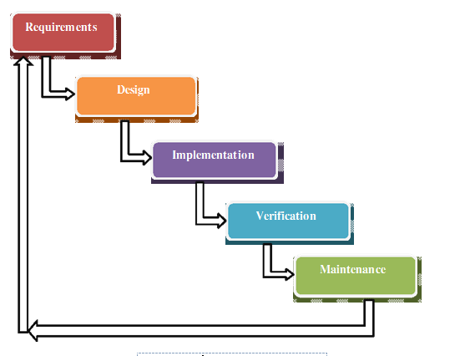

Fig 5.2.1 showing Waterfall Model.

## System Architecture

System architecture is the conceptual design that defines the structure and behaviour of a

system. An architecture description is a formal description of a system, organized in a way that supports reasoning about the structural properties of the system. It defines the system components or building blocks and provides a plan from which products can be procured, and systems developed, that will work together to implement the overall system.

The system architecture is as shown below:

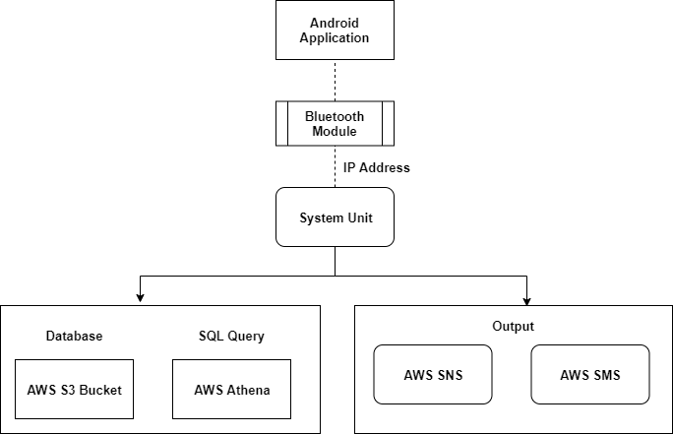

##### Figure 5.3: Architecture Diagram

* 1. **CLASS DIAGRAM**

A class diagram in the Unified Modelling Language (UML) is a type of static structure diagram that describes the structure of a system by showing the system's classes, their attributes, and the relationships between the classes.

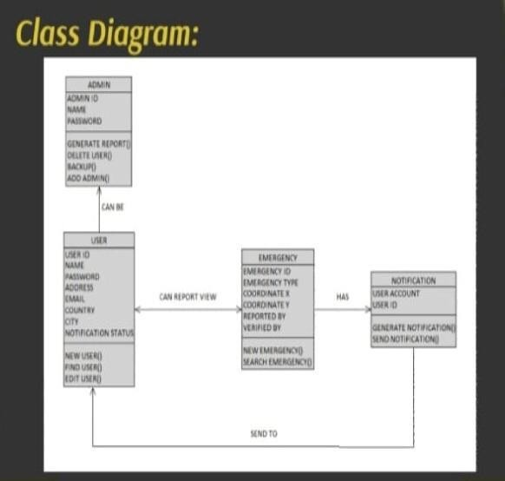

##### Figure 5.4: Class Diagram

The is an example for class diagram which describes the relation between different classes. ADMIN,USER,EMERGENCY,NOTIFICATION are the classes which has attributes in it (Ex:USER ID,NAME, etc).

USER can be an ADMIN and USER can view report of EMERGENCY and visa versa like EMERGENCY can be reported by USER,EMERGENCY has some NOTIFICATION which will be sent to USER.

## USECASE DIAGRAM

A use case diagram is a type of behavioral diagram created from a Use-case analysis. Its purpose is to present a graphical overview of the functionality provided by a system in terms of actors, their goals (represented as use cases), and any dependencies between those use cases

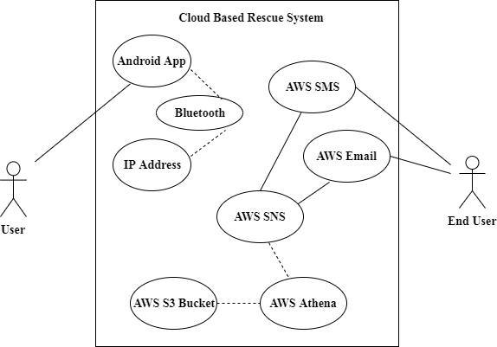

##### Figure 5.5: Use case Diagram

Here the Oval represent the different use cases,Users and End Users are the actors that are interacting.

The line between the actors and use cases are the asscociated with(which actors are associated with which use cases).The box is the system boundary boxes that sets a system scope to use cases.

IP address, the AWS S3 is a storage service that provide object storage service that provides object storage through a web service interface.Amazon Athena is an interactive query service that makes it easy to analyze data directly in Amazon S3 using standard SQL.AWS SNS is a web service that coordinates and manages the delivery or sending of messages to subscribing endpoints or clients.

AWS server migration service(SMS) is an agentless service which makes it easier and faster for you to migrate thousands of on-premises workloads to AWS.AWS SMS allows you to automate,schedule,and track incremental replications of live server volumes,making it easier for you to coordinate large-scale server migrations,and which is later interacted with the end user through SMS or Email.

## SEQUENCE DIAGRAM

A sequence diagram in Unified Modeling Language (UML) is a kind of interaction diagram that shows how processes operate with one another and in what order. It is a construct of a Message Sequence Chart.

The sequence diagram is shown below:

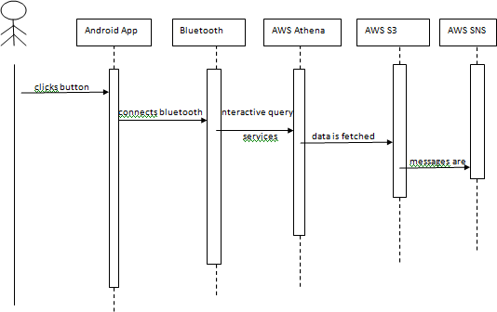

##### Figure 5.6: Sequence Diagram

The rectangle box represents the component used,the rectangle placed vertically represents the activation or execution occurrence and arrow represents the synchronous messages.

So here the user clicks a button on android app which in turn connects to the Bluetooth and using AWS Athena the interactive query services are sent to AWS S3.This AWS S3 fetches to data and then messages are sent to AWS SNS which manages the delivery or sending of messages to End users.

Summary

This chapter mainly concentrates on system architecture, class diagram, sequence diagram, use-case diagram, data flow diagram etc.

## CHAPTER 6

**IMPLEMENTATION**

Implementation is the stage of the project where the theoretical design is turned into a working system. At this stage the main workload and the major impact on the existing system shifts to the user department. If the implementation is not carefully planned and controlled, it can cause chaos and confusion.

The implementation stage requires the following tasks.

1. Careful planning.
2. Investigation of system and constraints.
3. Design of methods to achieve the changeover.
4. Evaluation of the changeover method.
5. Correct decisions regarding selection of the platform.
6. Appropriate selection of the language for application development.

## Language used for implementation

Implementation phase should perfectly map the design document in a suitable programming language in order to achieve the necessary final and correct product. Often the product contains flaws and gets ruined due to incorrect programming language chosen for implementation.

In this project, for implementation purpose Python is chosen as the programming language. Few reasons for which Python is selected as a programming language can be outlined as follows:-

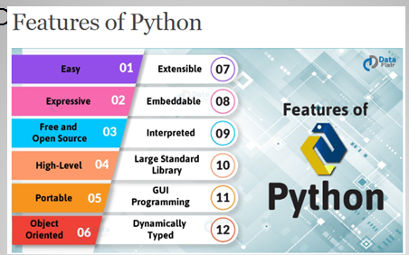

**Fig 6.1 showing a features and reasons to use python.**

* **Easy to learn and use:** It is developer-friendly and high programming language.
* **Expressive language:** Python ,language is more expressive means that it is more understandable and readable.
* **Interpreted language:** Interpreter executes the code line by line at a time.This makes debugging easy and thus suitable for begginers.
* **Cross-platform language:** python can run equally on different platforms such as windows,linux,unix and macintosh etc.so
* **Free and open source:** It is freely available at official web address the source-code is also available therefore it is open source.
* **Object-Oriented language:** It supports for the concepts of classes and objects come into existence.
* **Large Standard Library:** provides rich set of module and functions for rapid application development.
* **GUI Programming and Integrated support:** Graphical user interfaces can be developed using python.It can be easily integrated with languages like c,c++,java etc.
  1. **Platform used for implementation**

### MIT App Inventor



**Fig 6.2.1 showing the snapshot of MIT APP INVENTOR**

MIT App Inventor is a drag-and-drop visual programming tool for designing and building fully functional mobile apps for Android. App Inventor promotes a new era of personal mobile computing in which people are empowered to design, create, and use personally meaningful mobile technology solutions for their daily lives, in endlessly unique situations. App Inventor's intuitive programming metaphor and incremental development capabilities allow the developer to focus on the logic for programming an app rather than the syntax of the coding language, fostering digital

literacy for all. Since it was moved from Google to MIT, a number of improvements have been added, and research projects are underway.

### Features:

* Access to most of the phone's functionality: phone calls, SMS texting, sensors for location, orientation, and acceleration, text-to-speech and speech recognition, sound, video.
* The ability to invoke other apps, with the Activity Starter component
* Programming control just as with a textual language. There are blocks for conditionals (if, if else), for each, and while, and a fairly comprehensive list of math and logic blocks.
* Database access, both on the device and on the web. So you can save data persistently, and with a web database share data amongst phones.Access to web information sources (APIs) -- you can bring in data from Facebook, Amazon.

## App Inventor’s design editor:

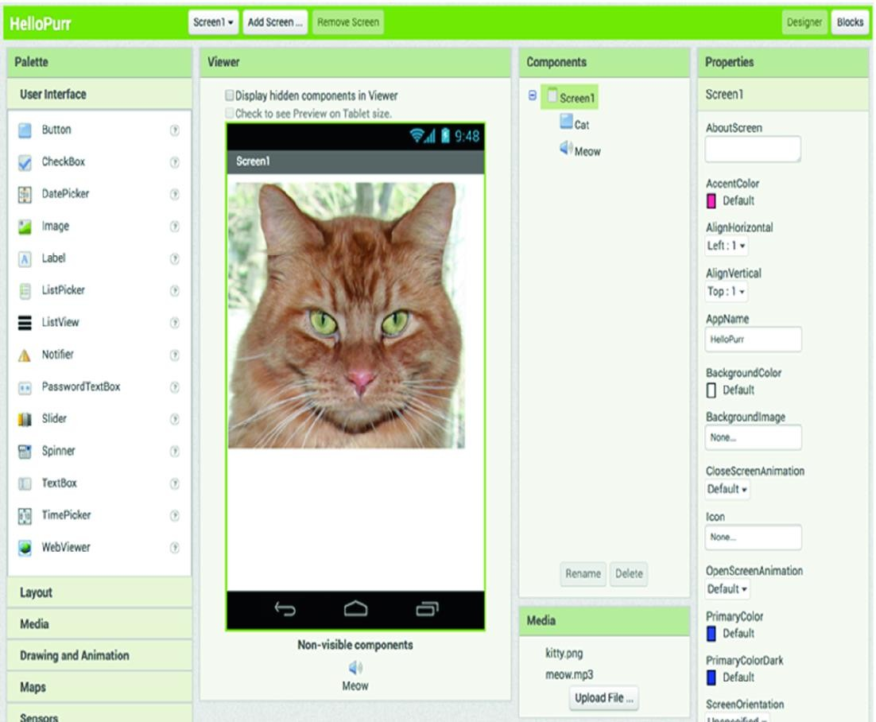

**Fig**

* App inventors drag components out from the palette (far left) to the viewer (center left) to add them to the app. Inventors can change the properties of the components (far right).
* An overview of the screen’s components and project media are also displayed (center right)

## App Inventor’s blocks editor:

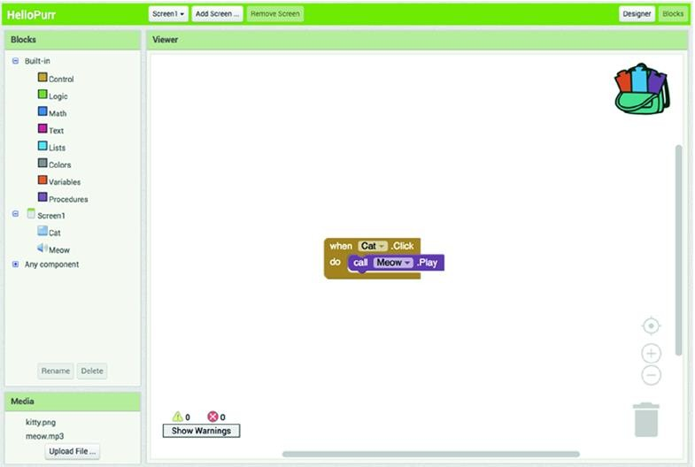

* + - * Blocks code is typically read left to right, top to bottom.
      * In this example, one would read “when Cat click, do call Meow play,” that is, play the meow sound when the cat is clicked

## Fast Iteration and Design Using the Companion

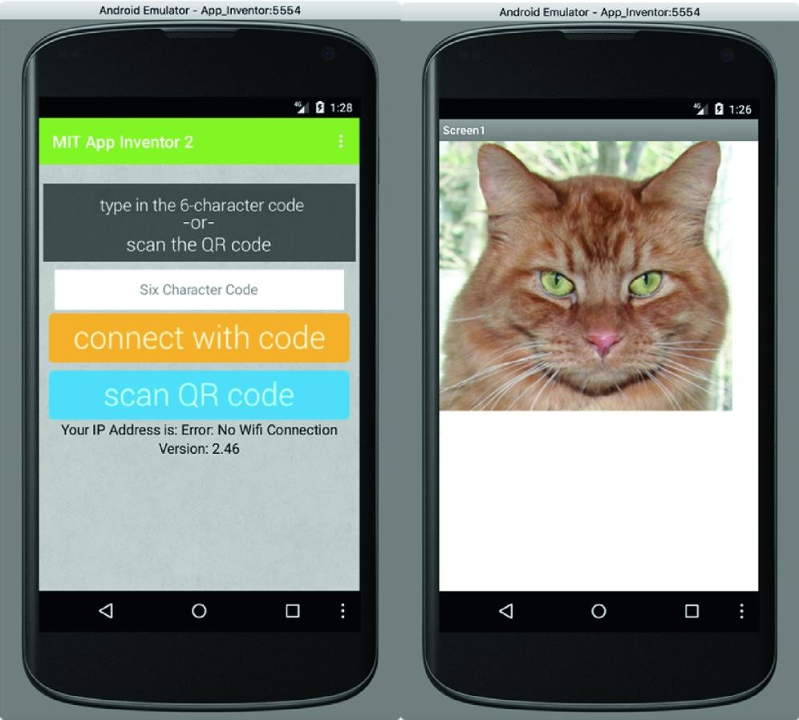

* + - * A key feature of MIT App Inventor is its live development environment for mobile application
      * The MIT Companion app interface for Android (left).
      * After establishing a connection with the user’s browser session, the active project is displayed in the companion app (right).

## BLUETOOTH MODEL

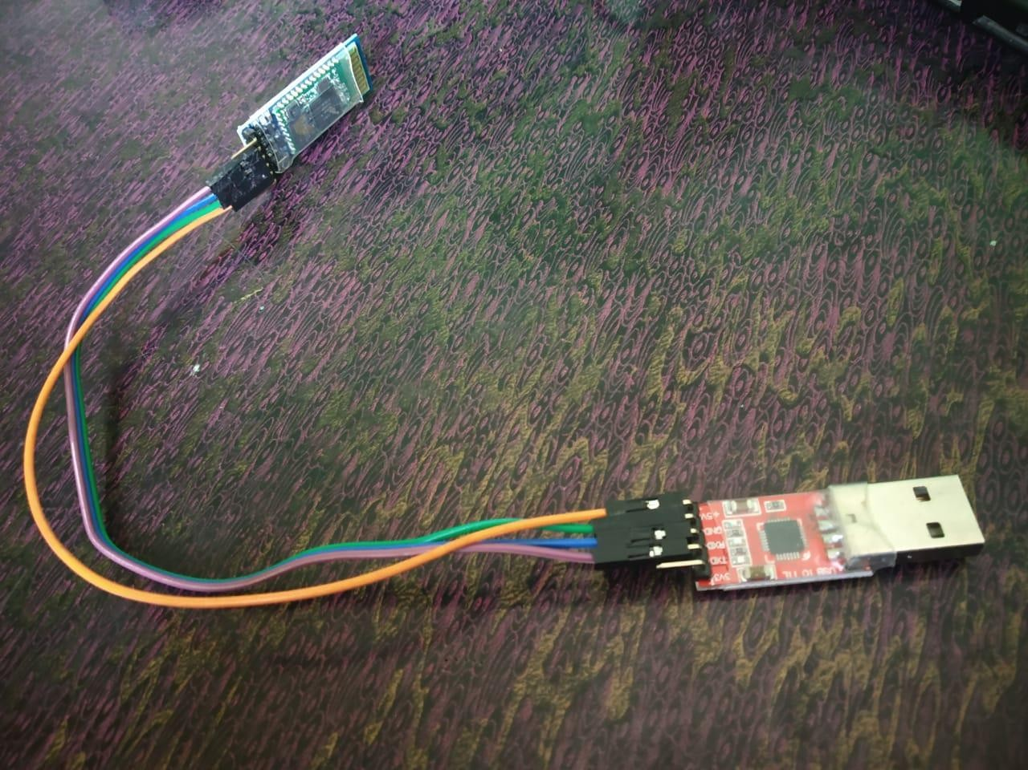

**HC**‐**05 module** is an easy to use **Bluetooth** SPP (Serial Port Protocol) **module**, designed for transparent wireless serial connection setup

* + - * **HC-05** uses the 2.45GHz frequency band.
      * The connection can be point-to-point or multi-point where the maximum range is **10meters.**
      * **HC-05** has **red LED** which indicates connection status, whether the bluetooth is connected or not.
      * Before connecting HC-05 module this red LED blinks continuously in a periodic manner.

## AWS CLOUD

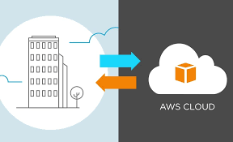

* + - * The Rescue System includes a user friendly android application and a system which runs with support of AWS Services.

## Coding Section

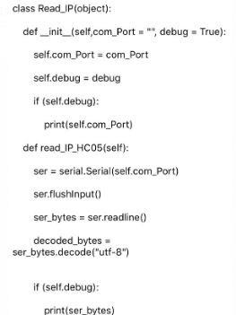

**MAIN FUNCTION**

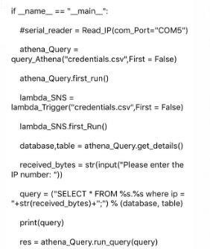

**AWS LAMDA SECTION**

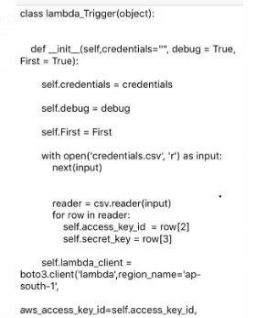

**CHAPTER 7**

**TESTING**

Testing is really a progression of various tests whose main role is to completely practice the PC based framework. Albeit every test has an alternate reason, all work to check that all the framework components have been legitimately coordinated and perform apportioned capacities. The testing procedure is really completed to ensure that the item precisely does likewise what should do. Testing is the last check and acceptance action inside of the association itself. In the testing stage following goals are tried to achieve: -

* + - * + To affirm the quality of the project.
        + To find and eliminate any residual errors from previous stages.
        + To validate the software as a solution to the original problem.
        + To provide operational reliability of the system.

During testing the major activities are concentrated on the examination and modification of the source code.

#### Unit Testing

Here each module that comprises the overall system is tested individually. Unit testing focuses verification efforts even in the smallest unit of software design in each module. This testing is known as “Module Testing”. The modules of the framework are tested independently. This testing is done in the programming style itself. Unit testing exercises specific paths in a module’s control structure to ensure complete coverage and maximum error detection. This test focuses on each module individually, ensuring that it functions properly as a unit. Hence, the naming is Unit Testing.

#### Integration

After successful completion of unit testing or module testing, individual functions are integrated into classes. Again, integration of different classes takes into place and finally integration of front- end with back-end occur.

#### Integration of functions into classes

At the start of coding phase only the functions required in different parts of the program are developed. Each of the functions is coded and tested independently. After verification of correctness of the distinct functions, they are integrated into their respective classes.

#### Integration of different classes

Here the different classes are tested independently for their functionality. After verification of correctness of outputs after testing each class, they are integrated together and tested again.

#### Integration of front-end with back-end

The front-end of the project is developed in Java Swing environment. The user interface is designed to facilitate the user to input various commands to the system and view the system’s normal and faulty behavior and its outputs. The back-end code is then integrated with the GUI and tested.

#### Integration Testing

Data can be lost across interface. One module can have an adverse effect on another. Sub functions when combined, should not reduce the desired major function. Integration testing is a systematic technique for constructing the program structure. It addresses the issues associated with the dual problems of verification and program construction. The main objective in this testing process is to take unit tested modules and build a program structure that has been dictated by design.

After the software has been integrated, a set of high order tests are conducted. All the modules are combined and tested as a whole. Here correction is difficult, because the isolation of errors is complicated by the vast expanse of the entire program.

#### 7.2.1 Top down Integration

This method is an incremental approach to the construction of program structure. Modules are integrated by moving downward, beginning with the main program module. Modules that subordinates to the main program module are incorporated into the structure in either depth first or breadth first manner.

#### 7.2.2. Bottom-up Integration

This method begins the construction and testing with the modules at the lowest level in the program structure. Since the modules are integrated from bottom to up, processing required for modules subordinate to a given level is always available. Therefore, in this case the needs for stubs is eliminated.The following integration testing table shows the functions that were combined into different classes and the class tested for its functionality. This is important to check for error free interaction between various classes, and maintenance of data integrity.

|  |  |  |  |
| --- | --- | --- | --- |
| **Classes integrated** | **Functions integrated in each class** | **Tests done** | **Remark s** |
| Class: Main | UploadDataset () Extract Features () Construct Predictive Model() | Class tested to check whether all operations that were applied are working correctly. | Success |
| Class: Feature Selection | Extract Dataset () selectContextModel () selectFeatures() | Class tested to check whether all operations that were applied are working correctly. | Succ |

|  |  |  |  |
| --- | --- | --- | --- |
| Class: Predictive Models | PredictDiseaseBasedOnNaive Bayes()  PredictDiseaseBased On Rando Forest()  predictDiseaseBasedOn Linear Regression() | Class tested to check whether all operations that were applied are working correctly and appropriately or not. | Success |

|  |  |  |  |
| --- | --- | --- | --- |
| Class: HDFS Interface() | Save Data() | Class tested to check whether all operations that were applied are working correctly. | Success |

**Table 7.2.2: Bottom-up integration table**

## Validation Testing

At the finish of combination testing, programming is finished and gathered as a bundle. Interfacing blunders are revealed and remedied. Approval testing can be characterized from multiple points of view. Here the testing approves the product capacity in a way that is sensibly expected by the client.

## Test cases

**CHAPTER 8**

**INTERPRETATION OF RESULT**

* In the newly proposed system the button will be available on the home screen of that android mobile
* As the user press the button or touch the screen the application will trigger in the background and immediately IP address of the user will send to the system unit installed in the apartment via Bluetooth.

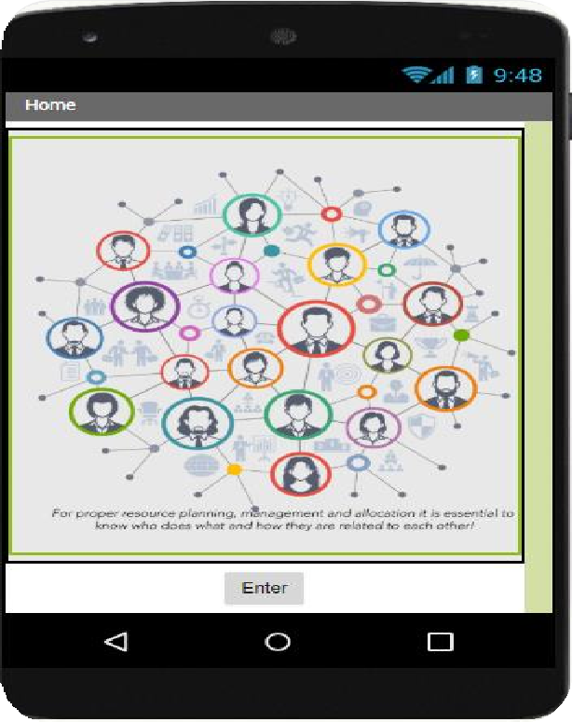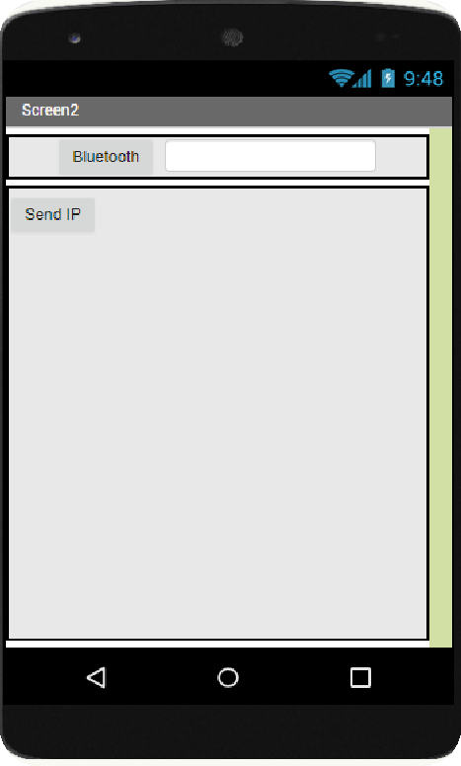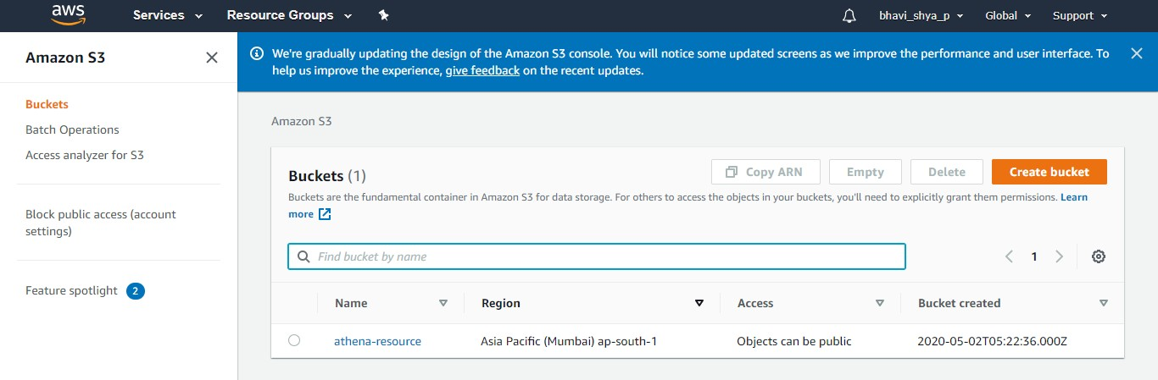

The above figure showing the creation of buckets by using Amazon s3 as shown in figure ,which helps us to store the data and makes us to access the data.

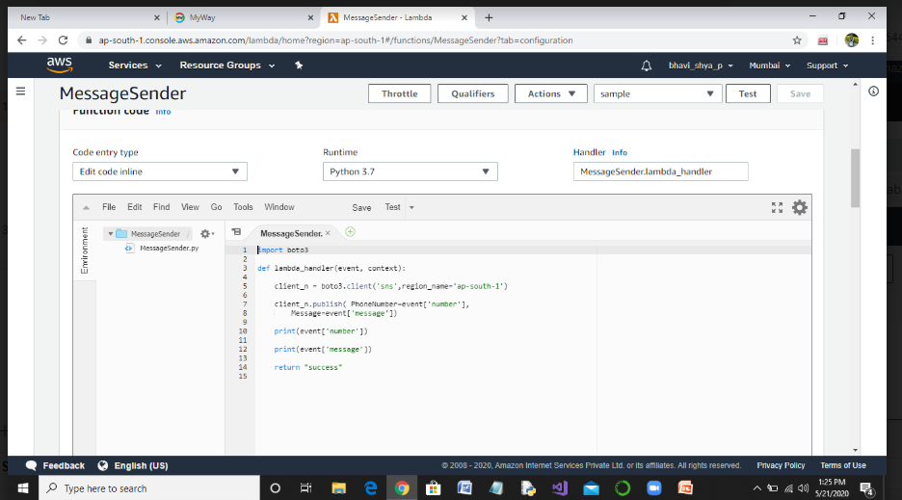

This snapshot showing lambda handler function that process the data given by the user that is it ask the name and number once it receives then it returns success as a message.

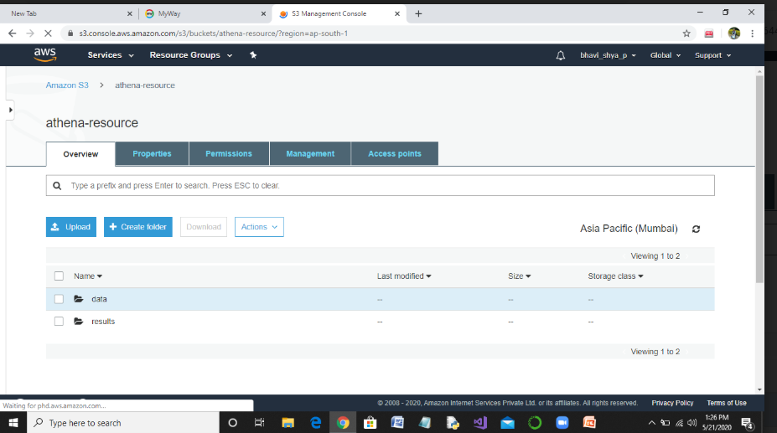

The above figure shows the snapshot of Athena resources where we can resources to upload, load, create folder, download etc.

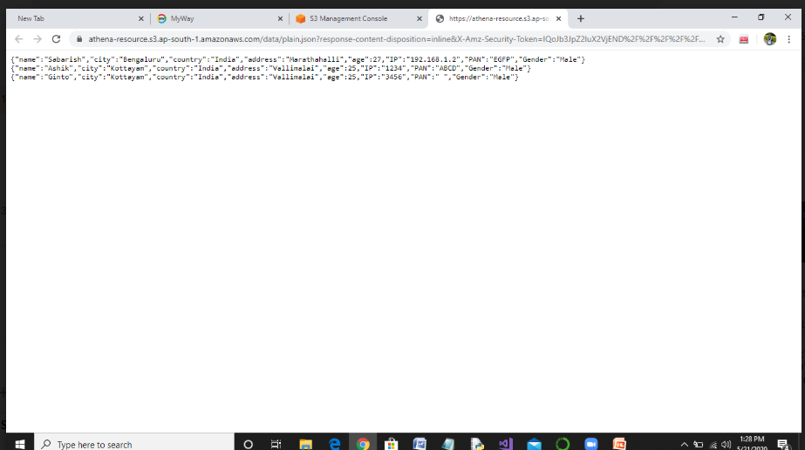

The snapshot showing the data stored. Here the data like name, city, country, address etc are stored.

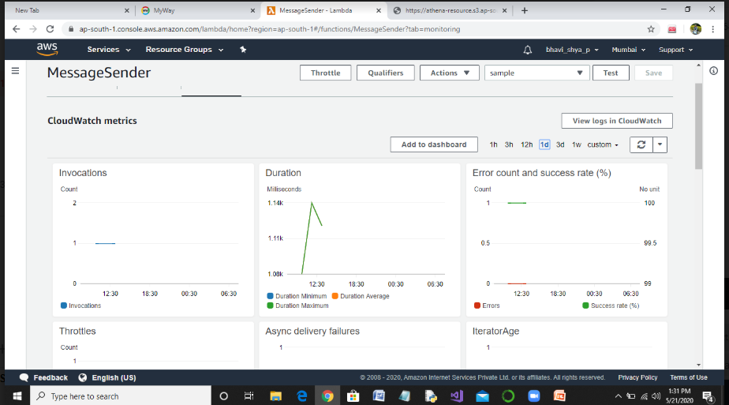

Amazon CloudWatch is a monitoring service for AWS cloud resources and the applications you run on AWS.You can use Amazon CloudWatch to collect and track metrics, collect and monitor log files set alarams, and automatically react to changes in your AWS resources.

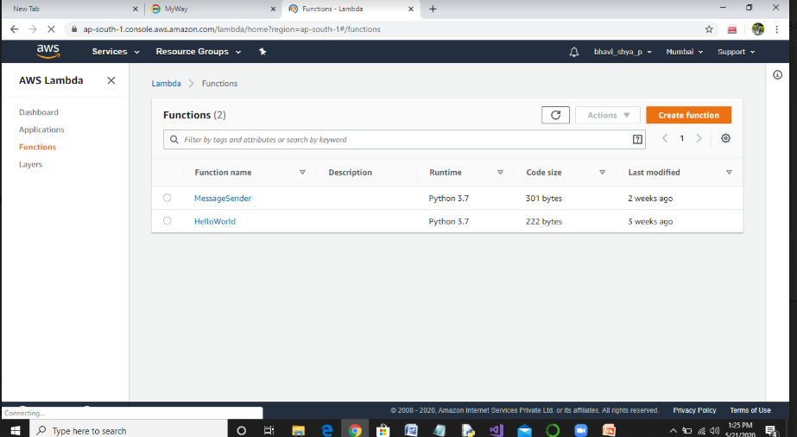

The above snapshot shows the usage of AWS Lambda function ,where we can see functions like Message Sender and Hello World , run time, code size etc.

# CONCLUSION AND FUTURE ENHANCEMENT

As we implemented the cloud based rescue system, we had created and tested a system which can be used during major emergencies/crisis events. This system enables better management of the first responders, health services, and victims located in the area of the event. The results from system usage could help in improving existing frameworks for major emergencies/crisis management.

As our project worked as we expected our future enhancement is to implement the same idea by using Wi-Fi (wireless fidelity) as of now we have implemented using Bluetooth module which has a short range of distance but in case of Wi-Fi we can increase the distance we can cover.